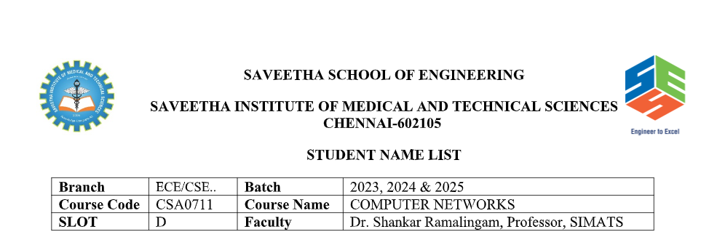
NAME: N.MOKSHITHA
REG.NO: 192411085
COURSE CODE: CSA0711
SLOT:D
COURSE NAME: COMPUTERNETWORKS

Question 4: Error Control Across OSI Layers

Concept Map Overview
Given Concept Map:
Error Control → Data Link Layer → Error Detection
→ Transport Layer → Error Correction

4.1 Introduction
In network communication, data is transmitted across unreliable media where noise, interference, and congestion can introduce errors. The OSI model addresses this through a layered error-control strategy where each layer contributes distinct, complementary mechanisms. The concept map illustrates how Error Control is the overarching principle implemented at two critical layers: the Data Link Layer (Layer 2) and the Transport Layer (Layer 4). Together, these layers form a robust, two-tier defence against data corruption and loss.

4.2 Data Link Layer – Error Detection
The Data Link Layer is responsible for hop-by-hop error control — it detects errors introduced during transmission on a single physical link before they propagate further.
- Cyclic Redundancy Check (CRC): A powerful polynomial-based technique that appends a check value to each frame. The receiver recomputes the CRC and compares; any mismatch signals a corrupted frame.
- Checksum: A simpler arithmetic sum of data bytes appended to each segment. Used in Ethernet and other link-layer protocols.
- Parity Bits: Adds a single bit to ensure the total number of 1-bits is even (even parity) or odd (odd parity). Used in serial communications and memory systems.
- Automatic Repeat reQuest (ARQ): When an error is detected, the receiver requests retransmission of the erroneous frame. Variants include Stop-and-Wait ARQ, Go-Back-N ARQ, and Selective Repeat ARQ.

4.3 Transport Layer – Error Correction
While the Data Link Layer handles per-hop reliability, the Transport Layer ensures end-to-end reliability across the entire path from source to destination. Its error correction mechanisms operate at a higher abstraction level:
- TCP Sequence Numbers & Acknowledgements: TCP assigns a sequence number to every byte transmitted. The receiver sends ACKs to confirm receipt. Missing ACKs trigger retransmission.
- Go-Back-N & Selective Repeat: These sliding-window protocols allow multiple outstanding unacknowledged segments, improving throughput while still correcting errors via retransmission.
- Forward Error Correction (FEC): Proactively adds redundant data so the receiver can reconstruct lost or corrupted data without retransmission. Used in real-time applications (VoIP, streaming) where retransmission would introduce unacceptable delay.
- Flow Control (Window Scaling): Prevents the sender from overwhelming the receiver, reducing the probability of buffer overflow-induced packet loss.
- Congestion Control (AIMD): TCP's Additive Increase Multiplicative Decrease algorithm adapts the sending rate to network conditions, reducing congestion-caused errors.

4.4 Concept Map Flowchart
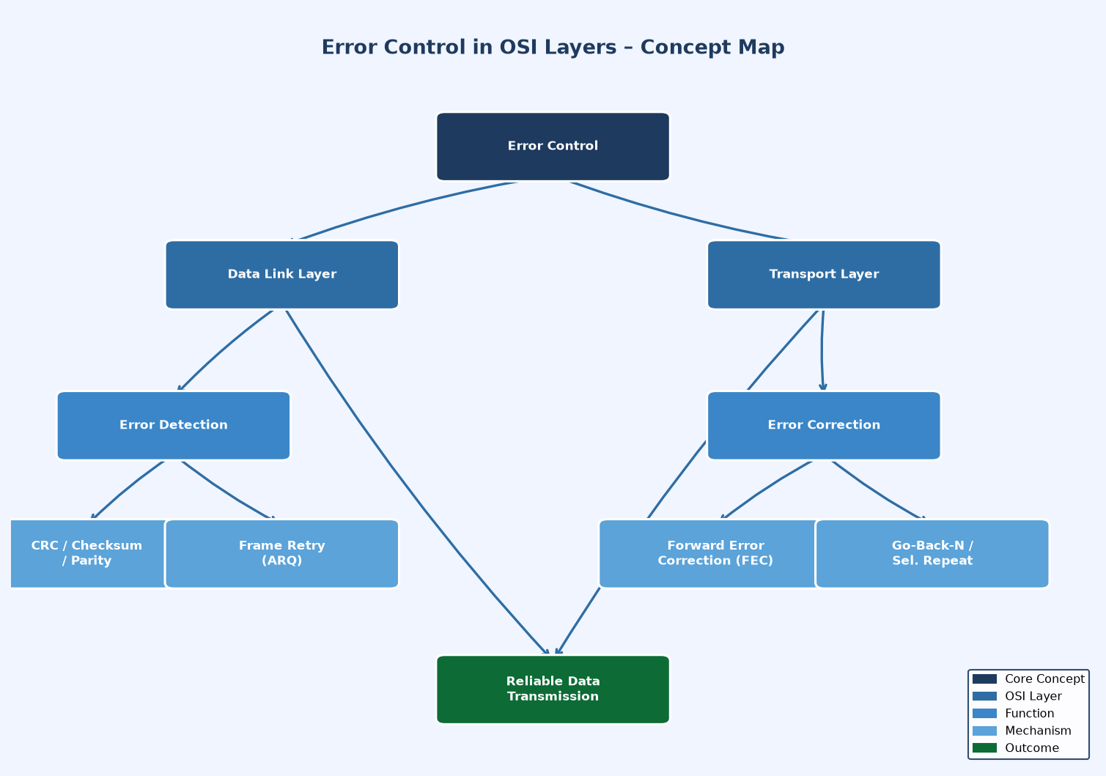
Figure 1: Error Control Concept Map – Data Link & Transport Layer Interaction

4.5 Interaction & Synergy – How Both Layers Improve Reliability
Aspect | Data Link Layer | Transport Layer
Scope | Hop-by-hop (single link) | End-to-end (source to destination)
Error Type | Detects bit errors in frames | Corrects segment loss/corruption
Mechanism | CRC, Parity, Checksum | FEC, Sequence Nos., ACK, ARQ
Response | Requests frame retransmission | Retransmits segments or uses FEC
Protocol Eg. | Ethernet, Wi-Fi (802.11) | TCP, SCTP, QUIC

4.6 Analysis & Conclusion
The layered error-control strategy creates a defence-in-depth approach to reliable transmission. The Data Link Layer acts as a first line of defence, detecting and signalling errors on a per-link basis before they can compound across multiple hops. However, since it only handles individual links, errors accumulated over multiple hops or introduced by network-layer processes remain unaddressed. The Transport Layer completes the reliability guarantee by providing end-to-end verification, ensuring that even if the Data Link Layer misses an error or data is lost in routers, the Transport Layer will detect and correct it. This two-layer synergy enables the Internet to deliver reliable communication over inherently unreliable physical infrastructure, achieving what neither layer could accomplish alone.

Question 5: Web Browsing Concept Map Using OSI Layers

5.1 Introduction
Web browsing is one of the most common networking activities, and it elegantly demonstrates the purpose of each OSI layer. When a user types a URL and presses Enter, a complex chain of events is triggered across all seven OSI layers. Each layer performs a specific function, and failure at any layer cascades downward (from the sender's perspective) or upward (from the receiver's perspective), disrupting the entire communication process. This question develops a comprehensive concept map for web browsing and analyses the impact of single-layer failures.

5.2 Web Browsing Concept Map Flowchart
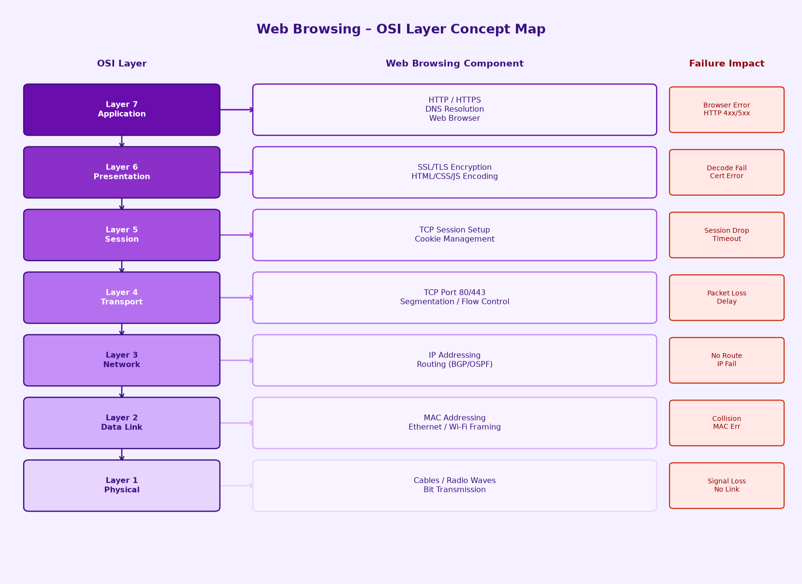
Figure 2: Web Browsing OSI Layer Concept Map with Failure Impact Analysis

5.3 Layer-by-Layer Web Browsing Analysis
■ Layer 7 – Application (HTTP/HTTPS, DNS)
The browser (e.g., Chrome) creates an HTTP GET request for the URL. DNS resolution converts the domain name (e.g., www.google.com) into an IP address. HTTPS adds authentication via certificates.
⚠ Failure Impact: HTTP 404/500 errors, DNS failure (website unreachable), incorrect web page rendered.
■ Layer 6 – Presentation (SSL/TLS, HTML Encoding)
Handles data format translation, encryption (TLS handshake for HTTPS), and compression. The browser decodes HTML, CSS, JavaScript from the server's encoding.
⚠ Failure Impact: SSL certificate errors (NET::ERR_CERT_AUTHORITY_INVALID), MIME type mismatch, garbled text if encoding fails.
■ Layer 5 – Session (TCP Session, Cookies)
Manages the session between the browser and the web server. Sets up, maintains, and tears down the TCP connection. HTTP cookies persist session state (login, cart).
⚠ Failure Impact: Session timeout, login state lost, repeated authentication prompts, broken persistent connections.
■ Layer 4 – Transport (TCP Port 80/443)
TCP segments the HTTP request, assigns port numbers (80 for HTTP, 443 for HTTPS), and ensures reliable, ordered delivery. Three-way handshake (SYN, SYN-ACK, ACK) establishes the connection.
⚠ Failure Impact: Connection refused (port blocked by firewall), packet loss causing slow loading, TCP timeout, high latency.
■ Layer 3 – Network (IP, Routing)
Assigns source and destination IP addresses. Routers use protocols (BGP, OSPF) to forward packets across the Internet to the destination server.
⚠ Failure Impact: Destination unreachable (no route), IP address conflict, incorrect routing sending packets to wrong destination.
■ Layer 2 – Data Link (MAC, Ethernet/Wi-Fi)
Frames the IP packets with MAC addresses for local network delivery. ARP (Address Resolution Protocol) maps IP addresses to MAC addresses on the LAN.
⚠ Failure Impact: ARP failure (host unreachable on LAN), MAC address spoofing, Wi-Fi authentication failure, frame collision errors.
■ Layer 1 – Physical (Cables, Radio Waves)
The actual physical medium – Ethernet cables, Wi-Fi radio waves, or fibre optic signals carry the bits as electrical, optical, or radio signals.
⚠ Failure Impact: Complete network outage, no connectivity, all upper-layer services fail immediately. Signal attenuation, cable break.

5.4 How Layer Failure Cascades
The OSI model's layered architecture means that failure is not isolated — it propagates. Consider a Physical Layer failure: since all upper layers depend on physical bit transmission, every layer above (Data Link, Network, Transport, Session, Presentation, Application) immediately ceases to function. A user would see no internet connectivity at all. Contrast this with an Application Layer failure (e.g., HTTP 404): only the specific resource is unavailable; the network itself remains functional. The lower the failure layer, the more widespread and catastrophic the impact.
Failure Layer | Layers Affected | User Experience
Physical (L1) | All 7 Layers | No internet – complete outage
Data Link (L2) | L2 through L7 | Cannot connect to local network
Network (L3) | L3 through L7 | Cannot reach websites (IP unreachable)
Transport (L4) | L4 through L7 | Connection timeout, slow loading
Session (L5) | L5 through L7 | Session drops, login issues
Presentation (L6) | L6 through L7 | Garbled content, SSL errors
Application (L7) | L7 only | HTTP errors, specific page failure

5.5 Conclusion
Web browsing demonstrates the interdependence of all OSI layers. The concept map reveals that reliability is a property of the entire stack, not any single layer. Network engineers and developers must understand this hierarchy to effectively diagnose issues: start from the Physical Layer upward to isolate the failure layer, then apply targeted remediation. The concept map serves as a diagnostic roadmap for troubleshooting web connectivity issues efficiently.

Question 6: Network Troubleshooting Using Concept Maps

Given Network Issue:
Physical ✔ → Data Link ✔ → Network ✖ → Transport ✖ → Application ✖

6.1 Introduction to Network Troubleshooting
Network troubleshooting is the systematic process of identifying, diagnosing, and resolving network issues. The OSI model provides a structured framework for troubleshooting by isolating problems to specific layers. The concept map presented here shows a real-world scenario: the Physical Layer and Data Link Layer are functioning correctly (✔), but the Network Layer fails (✖), causing cascading failures in the Transport Layer and Application Layer. This is a classic "can ping local network but cannot access the Internet" scenario.

6.2 Concept Map Flowchart – Troubleshooting Diagram
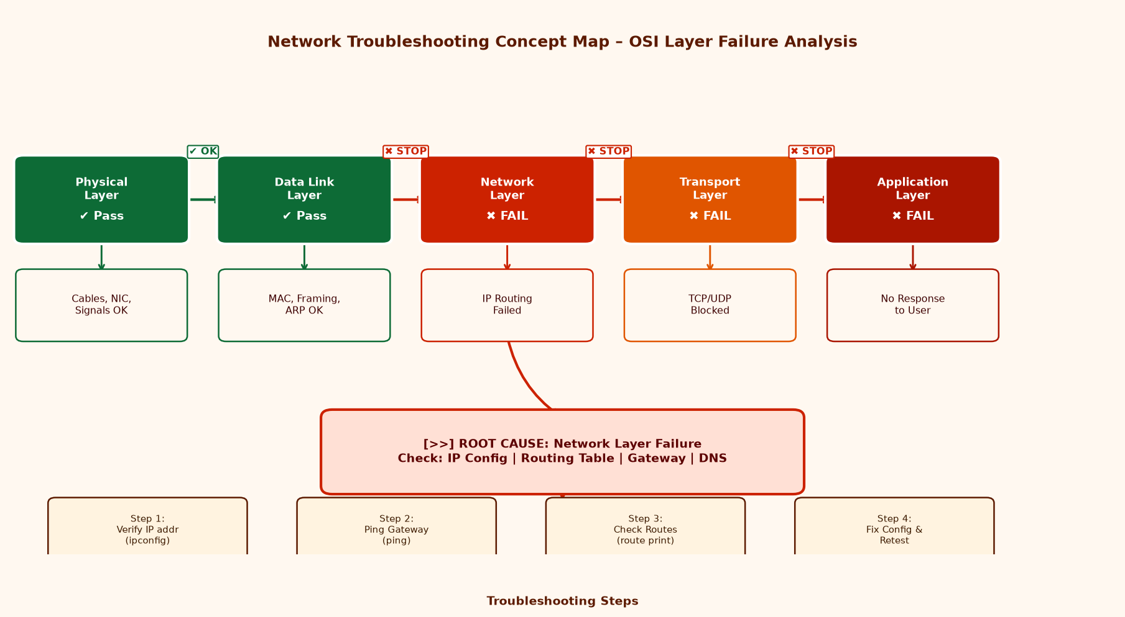
Figure 3: Network Troubleshooting Concept Map – OSI Layer Failure Cascade Analysis

6.3 Layer-by-Layer Status Analysis
Physical Layer (✔ PASS)
The Physical Layer is operational. This means the network interface card (NIC) is active, cables are connected, Wi-Fi or Ethernet link is established, and electrical/optical/radio signals are being transmitted. Verified by: checking link lights on NIC/switch, running `ping 127.0.0.1` (loopback test).
Indicators: Link light ON, `ping 127.0.0.1` succeeds, NIC driver loaded

Data Link Layer (✔ PASS)
The Data Link Layer is functional. MAC addressing, ARP resolution, and frame delivery on the local network are working. The device can communicate with other devices on the same LAN segment. Verified by: running `arp -a` shows local MAC entries, `ping <gateway-IP>` may succeed at this level.
Indicators: ARP table populated, local network devices reachable, frame check OK

Network Layer (✖ FAIL)
The Network Layer is failing. This is the root cause of the issue. The device cannot route packets beyond the local network. Possible causes include: (1) Incorrect or missing IP address, (2) Wrong or missing default gateway, (3) Incorrect subnet mask, (4) DHCP server not responding, (5) Routing table misconfiguration, (6) Router/firewall blocking ICMP.
Indicators: Cannot ping external IPs, `tracert` fails at first hop, `ipconfig` shows 169.x.x.x APIPA

Transport Layer (✖ FAIL)
The Transport Layer failure is a cascading consequence of the Network Layer failure. Since IP packets cannot be routed, TCP and UDP connections cannot be established. Port 80/443 connections time out. No TCP three-way handshake can complete.
Indicators: Connection timeout, TCP handshake fails, services unreachable

Application Layer (✖ FAIL)
The Application Layer fails because neither TCP nor UDP can deliver its data. Web browsers show "ERR_CONNECTION_TIMED_OUT", DNS resolution fails (DNS uses UDP), email clients cannot connect to mail servers, and all internet-facing applications fail.
Indicators: Browser shows error, DNS failure, no internet access, email/apps fail

6.4 Root Cause Analysis
The concept map pattern (Physical ✔, Data Link ✔, Network ✖) is the classic signature of a Network Layer configuration problem. Since lower layers pass and upper layers fail, the fault is precisely localised to Layer 3. The most common root causes in order of likelihood are:
- APIPA Address (169.254.x.x): DHCP server unreachable; device self-assigned a link-local address. Fix: Check DHCP server, run `ipconfig /release` then `ipconfig /renew`.
- Missing Default Gateway: The routing table lacks a default route. All non-local traffic is dropped. Fix: Add gateway via `route add 0.0.0.0 mask 0.0.0.0 <gateway-ip>`.
- Incorrect Subnet Mask: Device believes remote hosts are on the local subnet. Fix: Correct subnet mask in IP configuration.
- Router/Gateway Down: The default gateway itself is unreachable or offline. Fix: Verify gateway device, check its interface, restart if necessary.
- ISP or WAN Link Failure: Gateway is reachable but Internet routing fails upstream. Fix: Contact ISP, check WAN interface status on router.

6.5 Systematic Troubleshooting Procedure
Step | Action / Command | Success Criterion
Step 1 – Verify Physical Connectivity | `ping 127.0.0.1` (loopback), check NIC link lights, verify cable/Wi-Fi status. | Loopback ping succeeds → Physical layer OK
Step 2 – Verify Data Link / Local Network | `arp -a` to check ARP cache, `ping <local-IP>` to verify LAN communication. | Local hosts reachable → Data Link layer OK
Step 3 – Check IP Configuration | `ipconfig /all` – verify IP address is not 169.x.x.x (APIPA), check subnet mask and default gateway. | IP is valid, gateway is configured
Step 4 – Ping the Default Gateway | `ping <default-gateway-IP>` – if this fails, gateway is unreachable at Layer 3. | Gateway responds → Local routing OK
Step 5 – Ping External IP (Bypassing DNS) | `ping 8.8.8.8` (Google DNS) – tests IP routing without DNS dependency. | If this fails but gateway ping succeeds → ISP/upstream routing issue
Step 6 – Test DNS Resolution | `nslookup google.com` – verifies DNS server is reachable and responding. | DNS resolves → Application layer can function
Step 7 – Apply Fix & Verify | Apply the appropriate fix (renew DHCP, add gateway, fix subnet mask). Re-test all steps to confirm resolution. | Full connectivity restored

6.6 How the Concept Map Aids Troubleshooting
The concept map transforms an abstract failure scenario into a visual, intuitive diagnostic tool. Its key benefits in troubleshooting are:
- Layer Isolation: The map immediately shows which layers pass (✔) and which fail (✖), narrowing the troubleshooting scope to the exact failure layer.
- Root Cause vs. Symptom Distinction: The concept map distinguishes between the root cause (Network Layer failure) and symptoms (Transport and Application failures), preventing engineers from treating symptoms instead of the underlying problem.
- Systematic Approach: Following the map from bottom (Physical) to top (Application) enforces the bottom-up troubleshooting methodology, the industry-standard approach.
- Communication Tool: The concept map serves as a common language between network engineers, helping teams quickly align on the problem scope during incident response.
- Preventive Design: By mapping dependencies, engineers can identify single points of failure and design redundant paths (e.g., dual ISP, redundant routing) to prevent recurrence.

6.7 Conclusion
The concept map pattern Physical ✔ → Data Link ✔ → Network ✖ is one of the most common real-world network problems, typically caused by DHCP failure, gateway misconfiguration, or ISP outage. The concept map approach accelerates diagnosis by providing a visual representation of the failure cascade, clearly distinguishing between the single root cause and its multiple downstream effects. By following the OSI-based troubleshooting methodology — testing from Physical upward and applying targeted fixes at the identified failure layer — network engineers can resolve issues efficiently, minimising downtime and service disruption. This structured approach transforms complex network problems into manageable, layer-specific diagnostic tasks.

